PRINCIPLES OF LINUX
OPERATING SYSTEMS
SUMMARY

Chapter 1 ,2 ,3, 4

Class: CNS241

Malyun Fu ‘ad Yusuf

DEPARTMENT: Networking and Cybersecurity

Chapter 1: Introduction to Linux and Ubuntu
Easy English – Important Exam Notes

1. What is an Operating System (OS)?
An Operating System is software that manages computer hardware and software. It helps users communicate with the computer.
Five main functions of an Operating System:
- CPU Management: Controls the CPU.
- Memory Management: Manages RAM.
- File Management: Manages files and folders.
- Hardware Control: Controls computer devices.
- User Interface: Allows users to interact with the computer.
Types of Operating Systems:
- Desktop OS – Windows, macOS, Ubuntu.
- Server OS – Ubuntu Server, Windows Server.
- Mobile OS – Android, iOS.
- Embedded OS – Used in routers, TVs and cars.

2. What is Linux?
Linux is an open-source operating system. Technically, Linux is the kernel of an operating system.
Term | Easy meaning
Kernel | The core of the operating system.
Distribution | A complete Linux-based operating system.
Desktop Environment | The graphical interface users see.

Examples of Linux distributions: Ubuntu, Debian, Fedora and Linux Mint.
Remember: Ubuntu is a Linux distribution. GNOME is a desktop environment.

3. History of Linux
Year | Important event
1960s–70s | Unix was developed at Bell Labs.
1983 | Richard Stallman started the GNU Project.
1991 | Linus Torvalds created the Linux Kernel.
1993 | Ian Murdock started Debian.
2004 | Mark Shuttleworth released Ubuntu.

Important: Linux follows Unix ideas, but Linux is not Unix.

4. Linux Kernel
The Kernel is the most important part of Linux. It connects software with computer hardware.
Six main responsibilities of the Kernel:
- Hardware Management
- Process Management
- Memory Management
- File Management
- Network Management
- Security Management
Linux System Architecture (from top to bottom):
- User
- Desktop (Optional)
- Applications
- Shell and Tools (Bash)
- Kernel
- Hardware

5. Linux Distributions and Families
Family | Examples | Package manager
Debian | Ubuntu, Mint | APT
Red Hat | Fedora, RHEL | DNF
SUSE | openSUSE | Zypper

Package formats: Debian uses .deb. Red Hat and SUSE commonly use .rpm.
Three types of distributions:
- Enterprise: Made for businesses and designed to be stable.
- Consumer: Made for normal users.
- Experimental: Uses new software and may have bugs.

6. Ubuntu Linux
Ubuntu is a Linux distribution based on Debian.
Ubuntu Desktop | Ubuntu Server
Has a graphical interface (GUI). | Usually uses the command line.
Used for personal computers. | Used for servers.
Comes with desktop applications. | Designed for server tasks.

LTS means Long Term Support. The chapter notes that LTS versions receive 5 years of support. New Ubuntu versions are released every 6 months, and new LTS versions every 2 years.
Example: Ubuntu 19.04 – 19 means the year 2019; 04 means April.

7. Why is Linux Important?
Advantages:
- Free to use.
- Open source.
- Very stable.
- Good for servers.
- Can run on old computers.
- Useful for networking and cybersecurity.
Disadvantages:
- Some Windows applications do not work on Linux.
- Some hardware needs extra drivers.
- The terminal can be difficult for beginners.
Linux is used in web servers, cloud computing, Android phones, supercomputers, routers and other devices.

8. Linux vs Windows vs macOS
Windows | macOS | Linux
Developed by Microsoft. | Developed by Apple. | Open-source system.
Common on PCs. | Used on Apple computers. | Common on servers.
Uses CMD and PowerShell. | Uses a Unix-style terminal. | Uses Bash and other shells.

Important: macOS is based on BSD Unix. Linux is Unix-like, but it is not Unix.

9. FOSS and Software Licences
FOSS means Free and Open Source Software. It gives users the freedom to use, study, change and share software.
Freedom | Meaning
Freedom 0 | Run the program.
Freedom 1 | Study and change the program.
Freedom 2 | Share copies with others.
Freedom 3 | Share modified versions.

Licence | Type
GNU GPL | Copyleft
GNU AGPL | Copyleft
MIT | Permissive
BSD | Permissive
Apache | Permissive

Copyleft: When you share modified software, you must keep the same freedoms for other users.
Permissive: Allows people to use and modify software with fewer restrictions, including in closed-source software.

Term | Easy meaning
Host OS | The main operating system on your computer.
Guest OS | The operating system inside the Virtual Machine.
Hypervisor | Software that creates and manages Virtual Machines.
Snapshot | Saves the current state of a Virtual Machine.

11. Basic Linux Commands
Command | What it does
whoami | Shows your username.
pwd | Shows your current location.
ls | Shows files and folders.
cat /etc/os-release | Shows Linux version information.
uname -r | Shows the Kernel version.

commands

- Whoami= shows your username
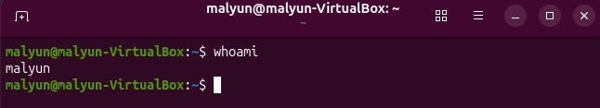
- Pwd= shows your current location
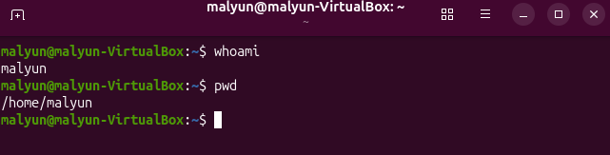

- Ls=shows files and folders
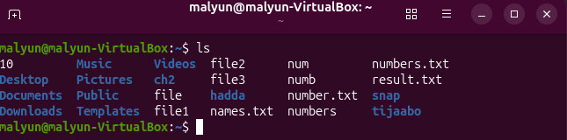

- cat /etc/os-release= Shows Linux version information.

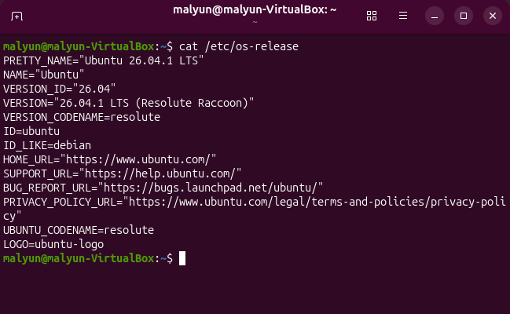

- Uname-r = shows the kernel version
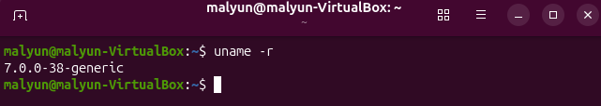

CHAPTER 2: LINUX SYSTEM ARCHITECTURE AND MANAGEMENT

1. Linux System Architecture
Linux system has different parts:
- Hardware: Physical parts of a computer, such as CPU, RAM, keyboard, and hard disk.
- Kernel: The core of Linux. It controls hardware and system resources.
- Shell: Allows users to communicate with the operating system using commands.
- Utilities: Tools used to perform different tasks.
- Applications: Programs used by users.
- Users: People who use the computer.

2. Linux Filesystem Hierarchy
Linux stores files and folders in one main directory called root /.
Important directories:
- / – Main directory.
- /home – Contains user files.
- /etc – Contains system configuration files.
- /usr – Contains programs and utilities.
- /var – Contains changing data, such as logs.

3. Terminal and Bash
- Terminal: The window where users type commands.
- Bash: The shell that reads and executes commands.
- Press the Up Arrow to see previous commands.
- Press Tab to complete commands or file names.
- Press Ctrl + R to search command history.

4. Linux Command Structure
A Linux command usually has three parts:
- Command name.
- Options.
- Arguments.
Example: ls -l /home
• ls = command.
• -l = option.
• /home = argument.

Getting Help in Linux = Linux provides different ways to get help:
  - man ls displays the manual.
  - ls –help displays short help information
  - info ls provides detailed documentation
  - help cd gives information about Bash built-in commands.

6. Quoting and Wildcards
Linux uses quotation marks and special characters.
- " " allows variable expansion.
- ' ' treats text literally.
- \ protects a special character.
- * matches many characters.
- ? matches one character.
- matches characters inside brackets.

7. Variables and PATH = PATH tells Linux where to search for commands.
Variables store information in the shell.
Example:
NAME=Ahmed
echo $NAME
export NAME
echo $PATH

8. Linux Paths
There are two main types of paths:
- Absolute path: Starts from /.
- Relative path: Starts from the current directory.
Important symbols:
- . means current directory.
- .. means parent directory.
- ~ means home directory.

9. Navigating Directories
These commands help users move between directories:
- pwd – Shows current directory.
- cd – Changes directory.
- cd .. – Moves to parent directory.
- cd ~ – Moves to home directory.
- cd - – Returns to the previous directory.
- ls – Lists files and directories.

10. Managing Files and Directories
Linux provides commands to create, copy, move, and delete files.
- touch – Creates an empty file.
- mkdir – Creates a directory/folder.
- rmdir – Removes an empty directory.
- cp – Copies files.
- mv – Moves or renames files.
- rm – Removes files.

Commands
1.pwd = meaning print working directory
2. cd change directory
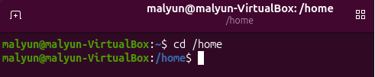
3.cd .. moves one level up
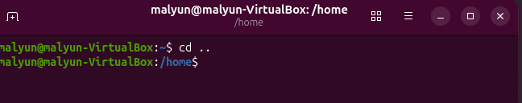
4.cd ~ moves to the users home directory
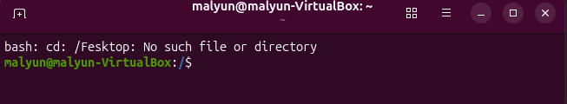
5.cd – return to the previous directory
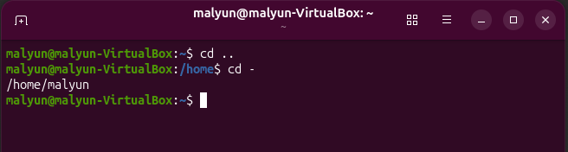
6.ls shows files in the current directory
- ls –a Shows all files, including hidden files.
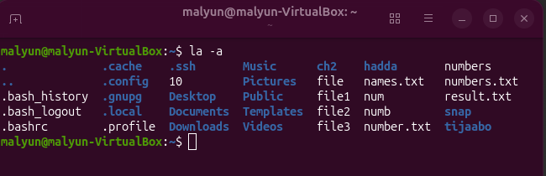
.ls –l -Shows detailed information.
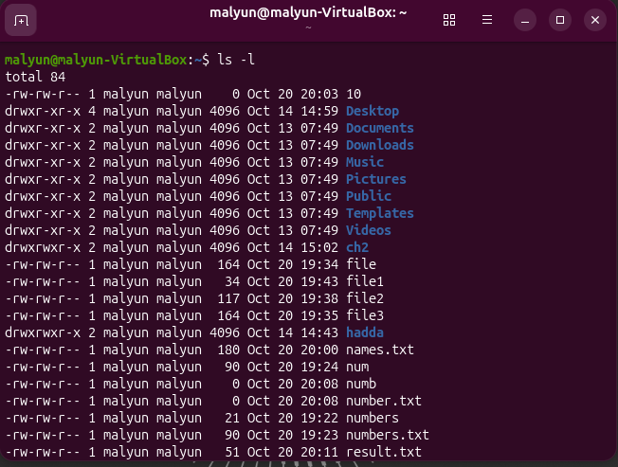
9.ls –lh
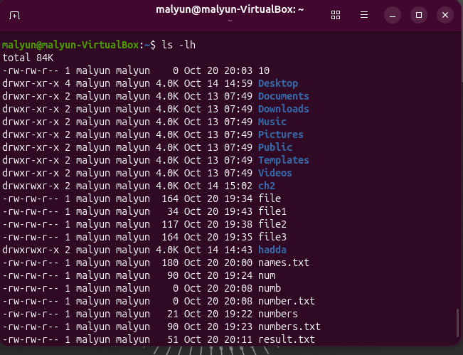
10.ls –lah
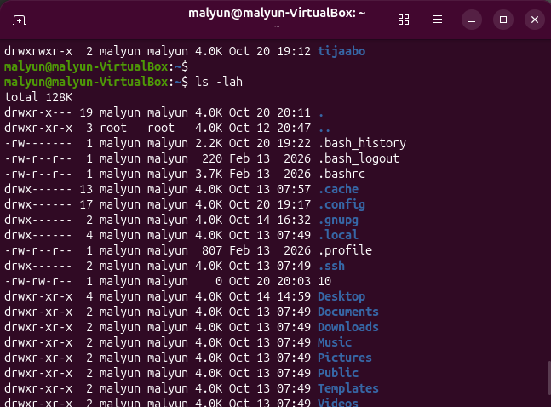
11.touch=Creates a file named notes.txt.
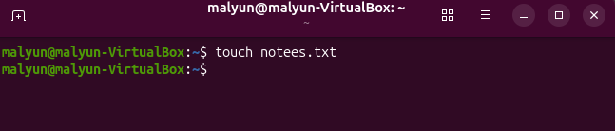

12 touch with multible files
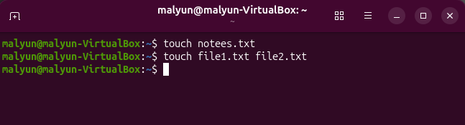
13.Mkdir=Creates a new directory.
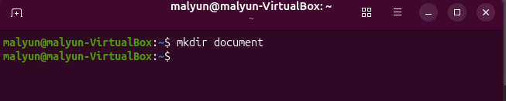

14.mkdir –p Creates the parent and child directories if they do not exist.
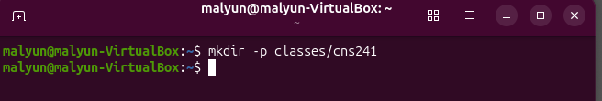

15.rmdir Removes an empty directory.
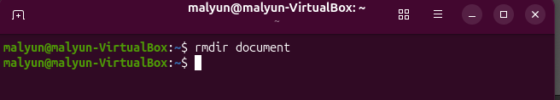
Note: It does not remove a directory containing files.

16.cp (copy) Copies files or directories.
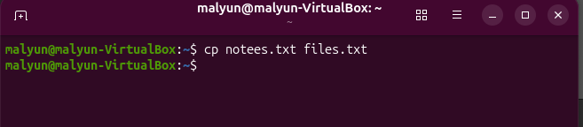

17.cp –r Copies a directory and its contents
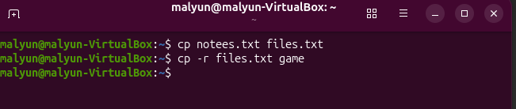

18.mv Moves files.
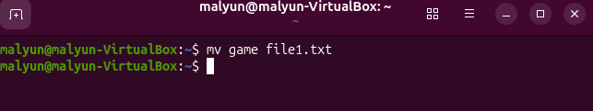

19.rmDeletes files.
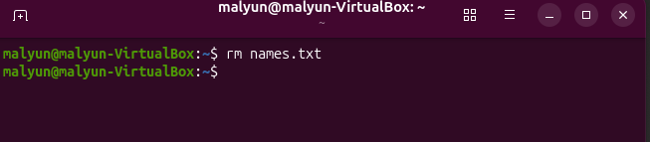

20.rm –i Asks for confirmation before deleting.
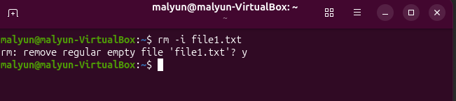
21. rm –r Deletes a directory and its contents.
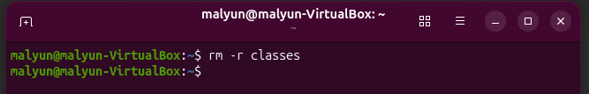
Warning: Be careful with rm -r because it can delete many files.
22. echo Displays text or variable values.
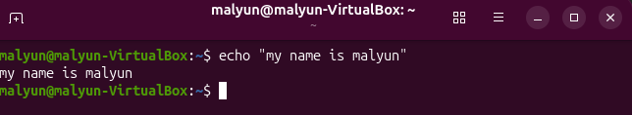
23.echo $path display the PATH variable
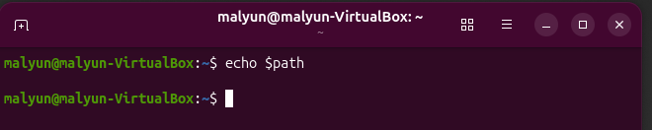
24. Manual (man) Shows the manual page for a command ex. Man ls= displays information about ls
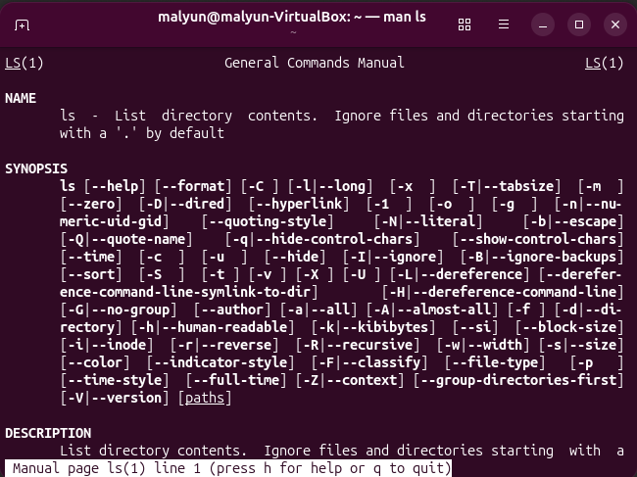
Press q to quit
25. –help Shows short help information.
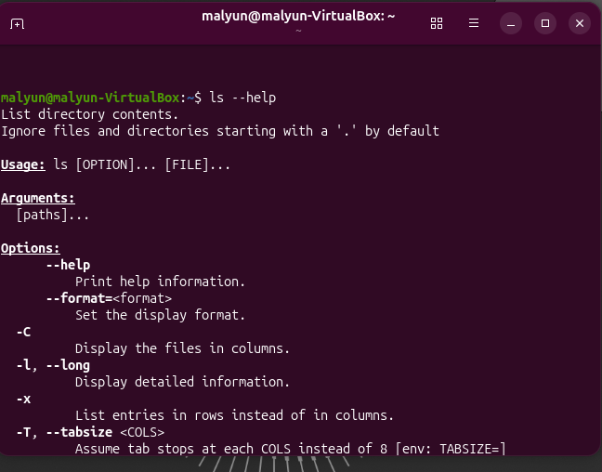

Displays the available options for ls

CHAPTER 3: TEXT PROCESSING, SEARCHING, ARCHIVING, AND EDITORS

This chapter explains how to read, search, process, organize, compress, edit, and link files in Linux.

1. Viewing and Searching Files
Linux provides commands to read files and search for information.
Important commands:
- cat – creates ,reading,copy ,concationation a file
- creating a file
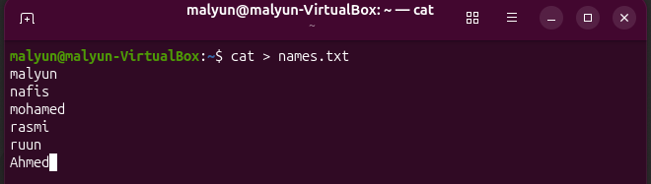
- reading a file
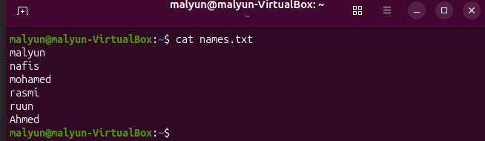

- copying a file
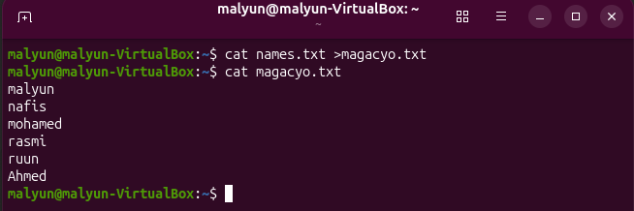

- concatenation files
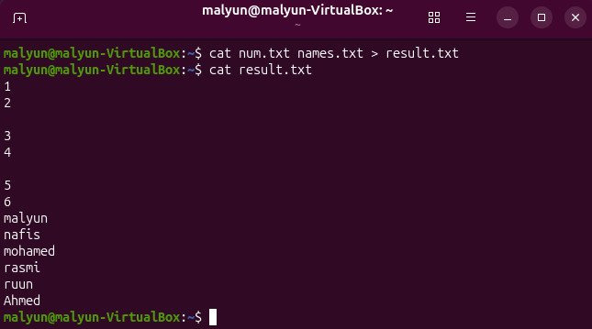

Cat options:
- –n : it makes numbers even spaces
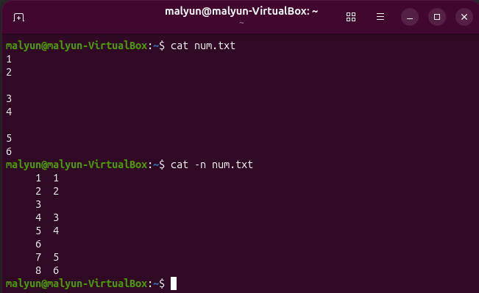
- –b :it makes numbers but not the spaces
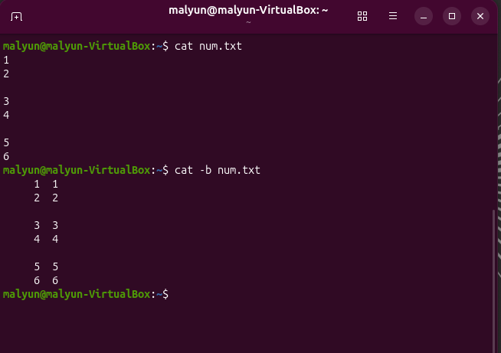
- –s :all spaces will be removed only one will remain
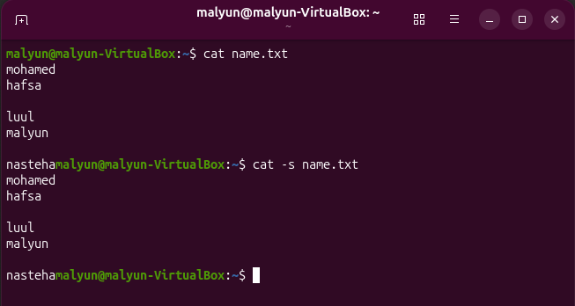
- –E :adds sign dollar $ to all lines
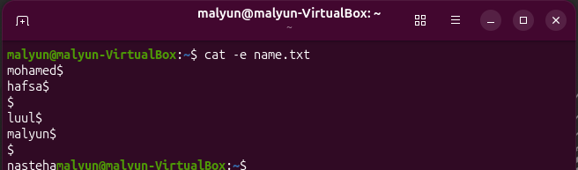
- less – Reads long files page by page.
Less options
Spce: bage to bage , b:go back , g:go to first line , G: go to the last page
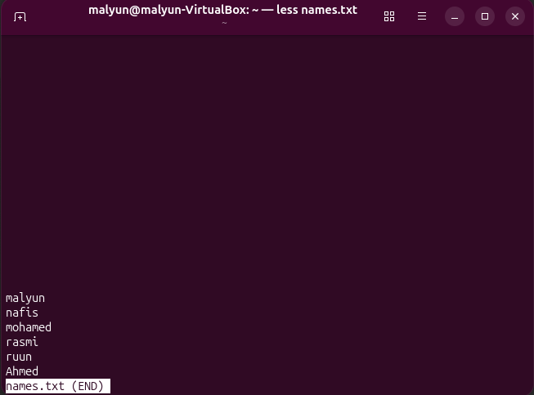
- more – Displays files one screen at a time.
More options: space and Enter
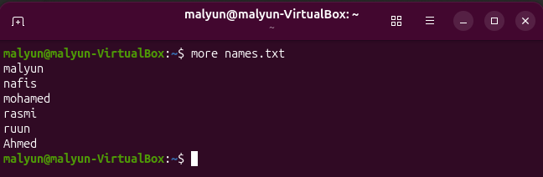

- head – Displays the beginning of a file automatically reads only 10 lines
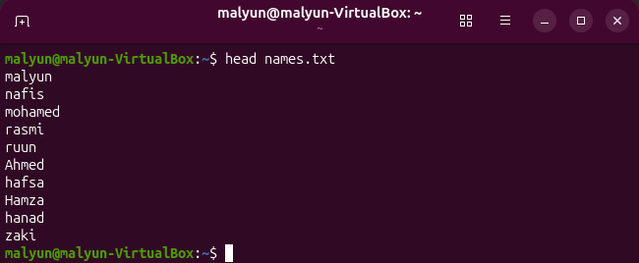
Options: -n tells how many lines will read
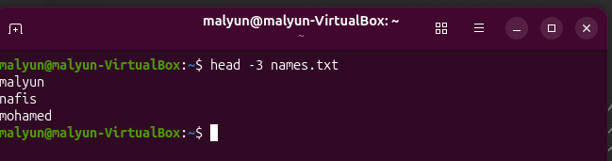
- tail – Displays the end of a file auto 10
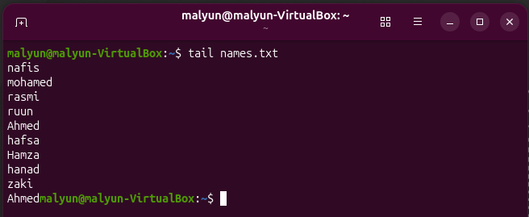

Options: -n tells how many lines will read
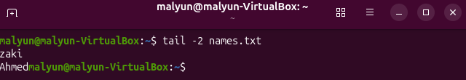
-f:
- this command is used to monitor a file in real time.
- it automatically displays new line added to the file.
- it’s usefull for monitoring system logs ,application logs ,and error logs.
- To stop moniroring ctrl+c
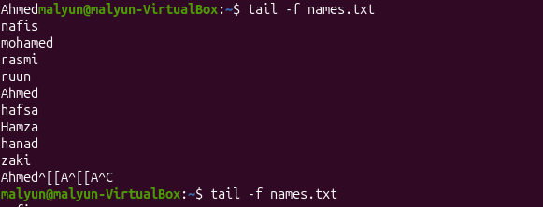

- file – Identifies the actual file type. 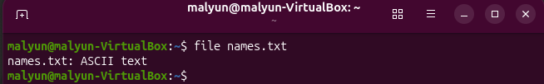
- stat – Displays detailed file information.
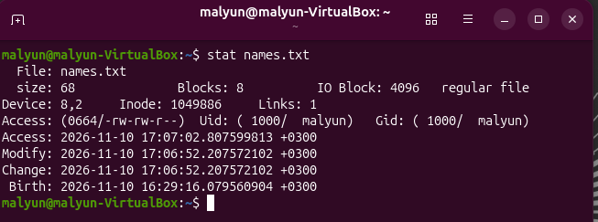
- which – Finds the location of an executable command. 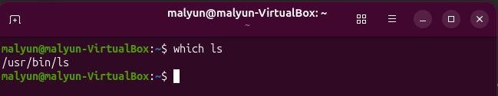
- Where is – Finds the location everywhere.
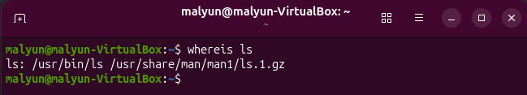
- Command –v - Shows how the shell resolves a command.
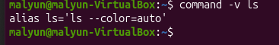
- find – Searches for files and directories.
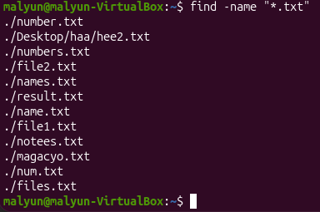
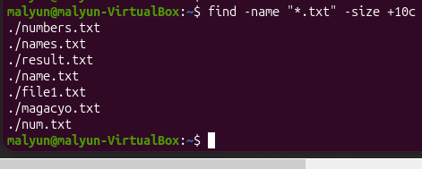
Options:
-name : finds exact match , case sensitive name !=Name
-lname: ignores case sensitive
Understanding size operators
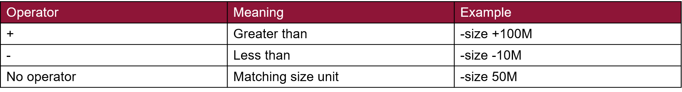
Common size units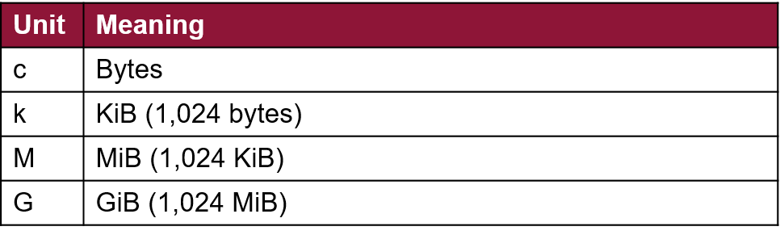
- locate – Quickly searches filenames using a database.
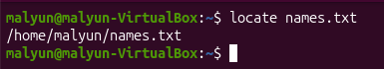
Choosing find or locate
The best tool depends on whether accuracy or a quick filename lookup matters
Find | Locate
- Scans actual directories at run time.  - Searches by type ,size , age ,name  - Best for fresh files /precise condition | - Searches a prebuilt filename database  - Usually faster for broad name searches  - Index may be stale / omit paths

- grep – Searches for words or patterns inside files.
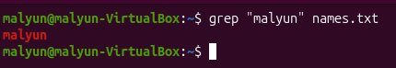
options:
-n: shows matching line numbers
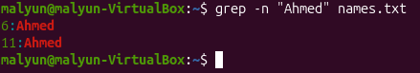
-i: Ignore uppercase and lowercase differences:
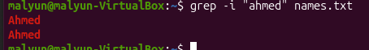
-v : Show lines that do not contain ERROR
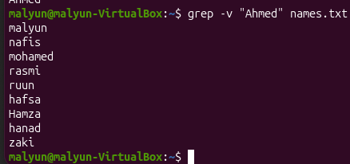
-rn: Search inside directories
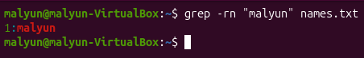
Search for lines ending with failed
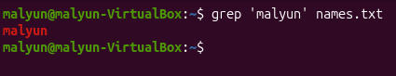

When to use it: When you want to find specific information inside files.

- Seq : displays numbers from first to last in step of ++
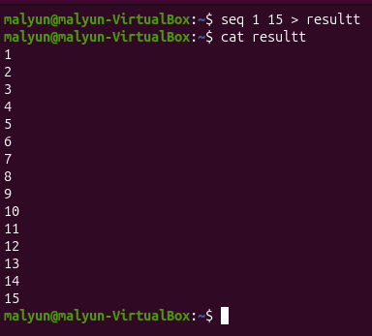

Difference Between Executable Commands and Shell Built-in Commands
In Linux, commands are divided into two main types: Executable Commands and Shell Built-in Commands.
1. Executable Commands
Executable commands are separate programs stored as files in the Linux filesystem. When a user enters a command, the shell searches for the program and executes it.
Examples:
- ls – Lists files and directories.
- cat – Displays file contents.
- date – Displays the current date and time.
- whoami – Displays the current username.
2. Shell Built-in Commands
Shell built-in commands are commands that are directly included inside the shell (such as Bash). They do not need separate executable files because the shell already understands and executes them.
Examples:
- cd – Changes the current directory.
- echo – Displays text on the terminal.
- alias – Creates command shortcuts.
- history – Displays previously used commands.

Main Differences
Executable Commands |  |  |  |  | Shell Built-in Commands
Separate programs stored as files. |  |  |  |  | Built directly into the shell.
Run as separate processes. |  |  |  |  | Usually run within the current shell.
Found in directories such as /bin and /usr/bin. |  |  |  |  | Do not require separate executable files.
Example: ls, cat, date. |  |  |  |  | Example: cd, alias, history.

How to Identify Command Types
Linux provides the type command to identify whether a command is executable or shell built-in.
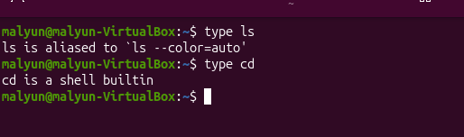
- type ls – Shows that ls is an executable command.
- type cd – Shows that cd is a shell built-in command.
Remember:
- Executable commands = Separate programs.
- Shell built-in commands = Commands built into the shell.

2. Redirection, Pipes, and Text Processing
Linux can send command output to files or another command.

Standard input (stdin) | 0 | receives input from the user / another sources
Standard output(stdout) | 1 | displays normal command result
Standard error (stderr) | 2 | displays error messages

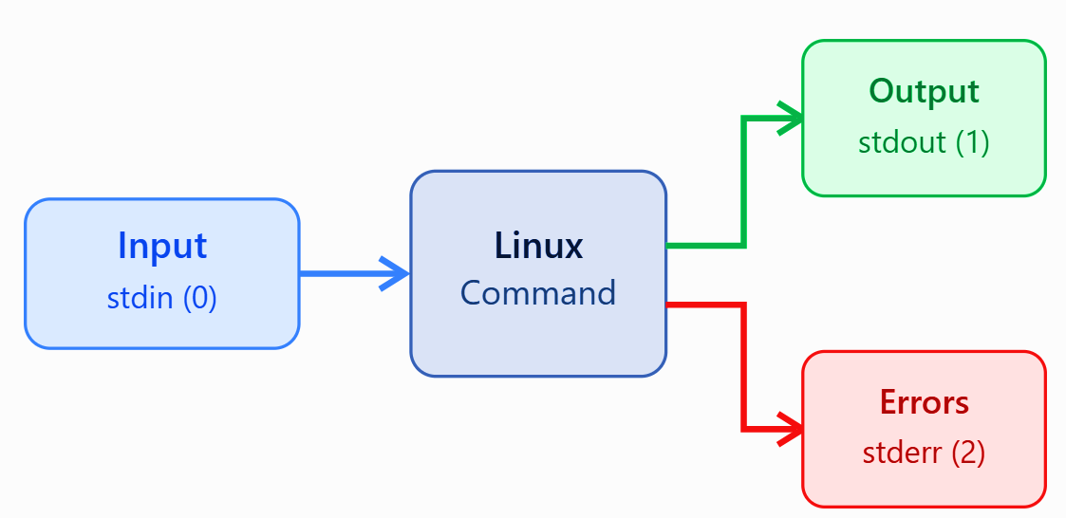
Important operators:
- > – Sends command output into a file. It creates the file or overwrites existing content..
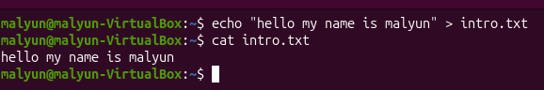
- >> – Adds information to the end of a file.
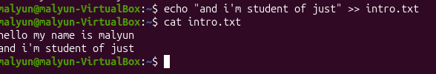

- 2> – Saves error messages.
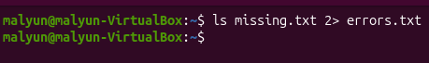
- < – Reads input from a file.
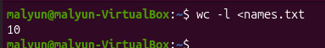
important text-processing commands:
- sort – Sorts lines.
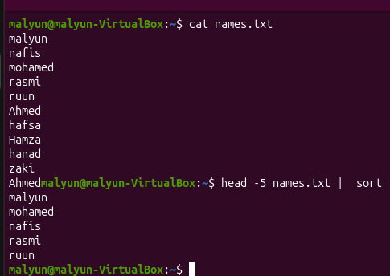

- uniq – Removes adjacent duplicate lines.

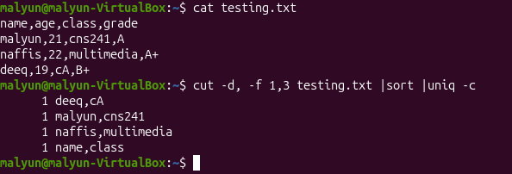
Options :
-d: shows dublication
-c: counts condecutive occurrence

- cut – Extracts specific fields or characters.
Options:
- –d: set colon ( : , ) as the delimiter
- –f : 1,3 retain fields 1 and 3
- –c: 1-4 would select between those numbers
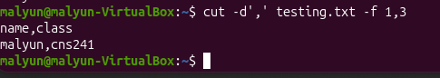
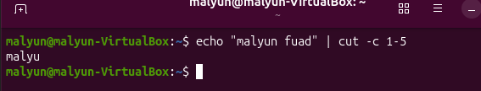
- paste – Combines lines from files.
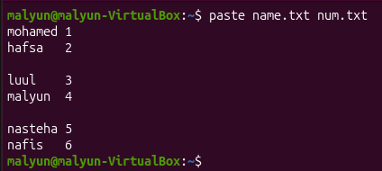
Options :
-d : changes the separator ( , : - )
-s : combines lines serially
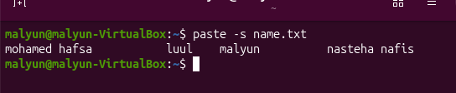
- wc – Counts lines, words, and bytes.
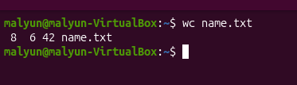
Options:
-l : counts lines
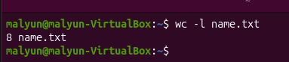
-w : counts words

-c : counts bytes
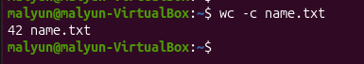
-m : counts characters
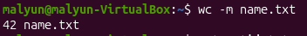
- tr – Translates, deletes, or replaces characters
tr -d: deletes selected chatacters
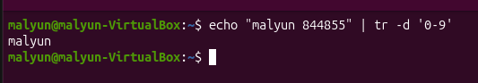
tr –s: deletes repeated spaces and remaining only one space

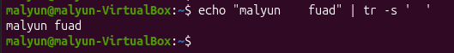
- Small to Capital letter
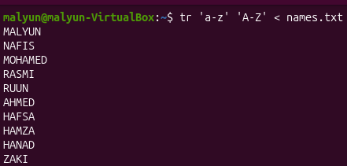

3. Archives and Compression
Archiving: combining multible files and folders into a single file to make storage and transfer easier . it does not reduce the total size.
Compression : Reducing the file size using algorithms to save space and speed up network transfer
NOTE: “ Archive first , then the compress”.
Archiving Compression
Combines multiple files into one file. Reduces the size of files.
Makes files easier to organize and share. Saves storage space.
Does not reduce file size. Reduces file size.
Uses formats like ZIP and TAR. Uses algorithms to reduce data size.
Makes file management easier. Makes file transfer faster.

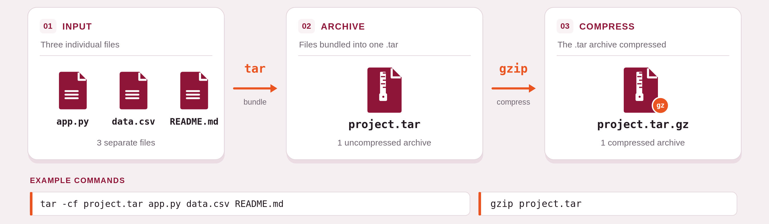Important commands:
- tar – Creates and extracts archives.

Option | Meaning
-c | Create archive
-x | Extract archive
-v | Display filenames
-f | Specify archive filename
-t | List archive contents
-C | Choose extraction directory
-z | Use gzip
-j | Use bzip2
-J | Use xz
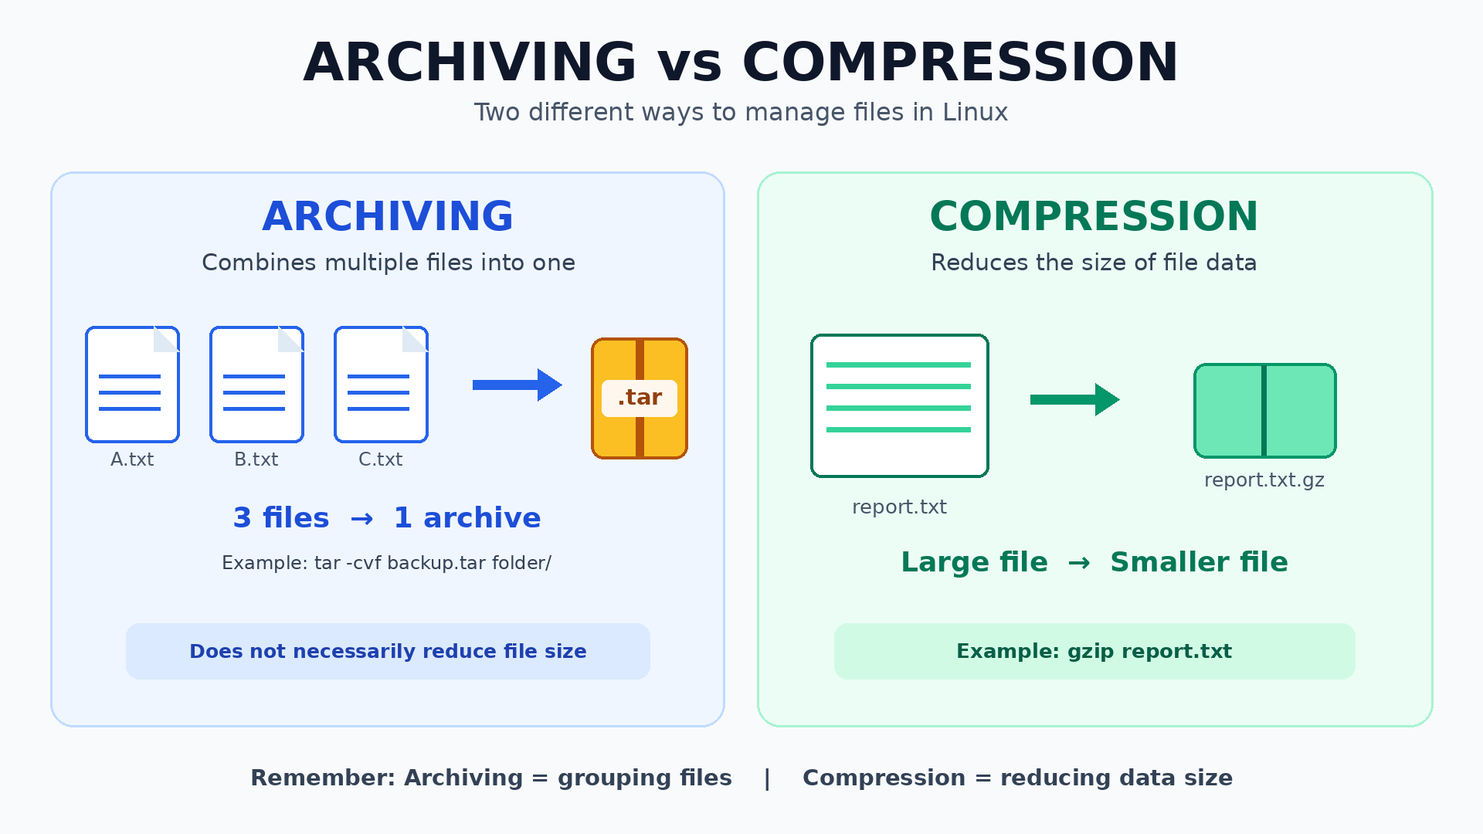
- gzip – Compresses files.
- gzip –k : Keep the original file
- Gzip -9 : Use the highest compression level
- When to use it: When reducing the size of individual files.
- gunzip – Decompresses .gz files.
- Gunzip –c : Display decompressed contents without removing the compressed archive
- bzip2 – Compresses files using bzip2.
- Bzip2 –k : The -k option keeps the original file.
- xz – Compresses files using xz.
- Xz –k : Display the decompressed contents
- zip – Creates ZIP archives.
  - Zip –r : The -r option includes subdirectories and their files
- unzip – Extracts ZIP archives.
  - Unzip –l : Extract into a specific directory

4. Text Editors: Nano and Vim
Linux has terminal editors for creating and editing text files.
Nano
- Easy for beginners.
- Uses keyboard shortcuts.
- Ctrl + O saves a file.
- Ctrl + X exits.
- Ctrl + W searches.
- Ctrl + K cuts a line.
- Ctrl + U pastes a line.
Vim
- Uses different editing modes.
- Normal mode is the starting mode.
- Insert mode allows typing text.
- Command-line mode allows saving and exiting.
- i enters Insert mode.
- Esc returns to Normal mode.
- :w saves.
- :q exits.
- :wq saves and exits.
- :q! exits without savin

5. Hard Links and Symbolic Links
Linux uses links to provide additional ways to access files.
Hard link
- Another filename pointing to the same inode.
- Both filenames share the same file data.
- Usually cannot link directories.
- Cannot normally cross filesystem boundaries.
Symbolic link
- A special file that stores a path to another file or directory.
- Can point to directories.
- Can point across filesystems.
- Can become broken if the target path changes.

Chapter 4 PROCESS, SERVICE, AND SYSTEM MANAGEMENT

4.1 | PROCESSES AND JOBS

1. Understanding a process
A process is a program that is running. When you open an application or type a command, Linux creates a process. The kernel gives every process a Process ID (PID). A process is started by another process called its parent. The parent's number is the Parent Process ID (PPID).
For example, the terminal window starts the Bash shell. Bash then starts the ps command when you type it. In this example, Bash is the parent of ps. The ps command is a child process.
Option / key | Meaning
PID | A unique number used to identify a running process.
PPID | The PID of the process that started the current process.
systemd (PID 1) | The first user-space process started by the kernel; it manages system services.
$$ | A Bash variable that contains the PID of the current shell.

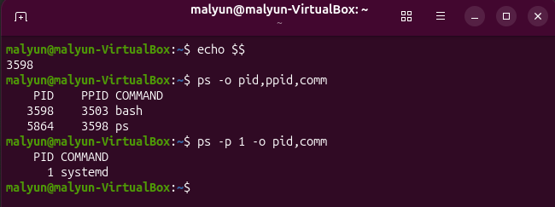
NOTE : a PID is not permanent. When a process ends, Linux can use that number again for another process.

2. ps — display a process snapshot
A process list is a picture of processes at one moment. The ps command displays this information. It does not continuously refresh. Run it again when you want an updated list.

Why do we use it?
Use ps when you need to identify a process, check its PID and PPID, see who owns it, or find a process before sending a signal.

Options / keys
Option / key | Meaning
ps | Shows processes connected to the current terminal.
-f | Full format. Adds information such as owner, PPID and start time.
-p PID | Shows only the process with the selected PID.
-o COLS | Selects the columns to display, such as pid,ppid,comm.
aux | BSD-style format showing processes from all users, with CPU and memory use.

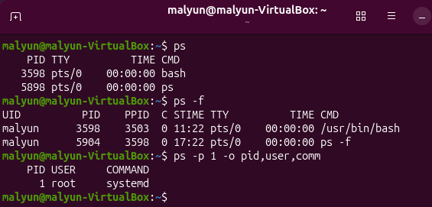

Important notes
- Use ps aux, not ps -aux, for the BSD-style form shown in this chapter.
- The PID in your VM will not be the same as the example.

3. ps aux — view all processes
The command ps aux displays processes belonging to all users. It also shows CPU and memory use. This list can be long, so the less command is used to read it one screen at a time.

Why do we use it?
Use ps aux when you want a wider view of what is running on the whole system, not only commands started in your current terminal.

Ps aux / less
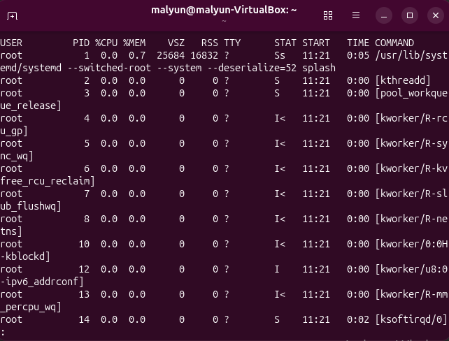

Options / keys
Option / key | Meaning
a | Show processes for users, not only the current terminal.
u | Use a user-oriented format with CPU and memory columns.
x | Include processes without a controlling terminal.
| less | Send the output to a pager. Press Space to move forward and q to quit.
--sort=-%mem | Sort by memory use, largest first. The minus sign means descending order.
head -n 5 | Display only the first five lines.

4. ps -ef and pstree — understand parent and child processes
ps -ef displays every process in a full format. The PPID column helps you identify the parent. The pstree command shows process relationships as a tree, so child processes appear under their parents.

Why do we use it?
Use these commands when you want to understand which process started another process or investigate a process family.
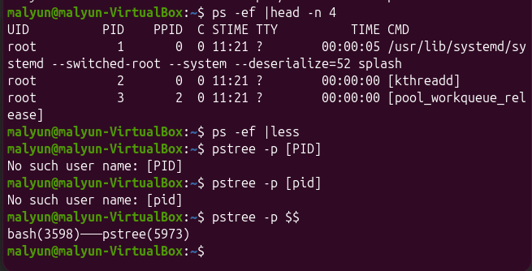

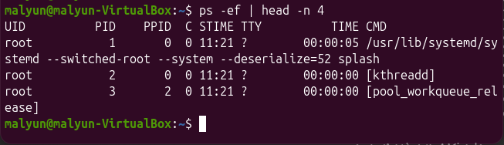

Options / keys
Option / key | Meaning
-e | Show every process.
-f | Use full-format output, including PPID.
-p (pstree) | Show process IDs in brackets after process names.
head -n 4 | Show only the first four lines.
less | Read long output page by page; press q to exit.

Important notes
- Names in square brackets in ps output can represent kernel threads.
- Choose either ps aux or ps -ef; do not mix both styles in one command.

5. top — live process monitoring
top displays a live view of processes and system activity. It refreshes the information every few seconds. It is useful when the computer is slow because it can show which process is using CPU or memory.

Why do we use it?
The first line shows the current time, how long the system has been running, logged-in users and load average. The Tasks line shows process states. The CPU line shows how busy the processor is. The memory line shows RAM use.
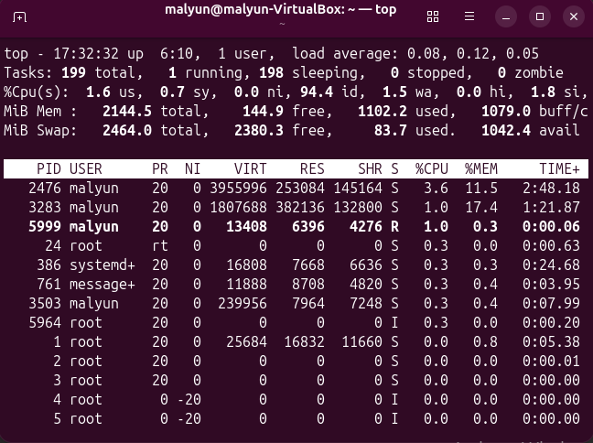

Options / keys
Option / key | Meaning
-u USER | Show processes belonging to one user.
-p PID | Monitor one selected process.
P (key) | Sort processes by CPU use.
M (key) | Sort processes by memory use.
k (key) | Send a signal to a selected process.
r (key) | Change a process priority (renice).
q (key) | Quit top.

Important notes
- A low id value on the CPU line means the CPU is busy.
- Press q to quit top. Ctrl+Z pauses it; it does not close it.

6. htop — a friendlier process viewer
htop provides a more visual process monitor. It displays colour bars, supports mouse interaction and provides function-key menus. It performs a similar job to top. If htop is not installed, use top instead.

Why do we use it?
Use htop when you prefer a visual display and want to sort, inspect or manage processes interactively.
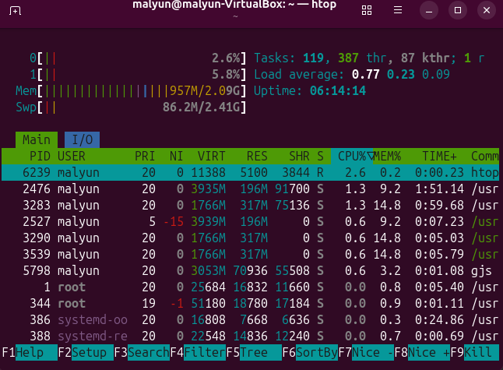

Options / keys
Option / key | Meaning
command -v htop | Checks whether the shell can find the htop command.
-u USER | Shows only the selected user's processes.
-t | Displays processes in a tree view.
F6 | Choose the column used for sorting.
F9 | Send a signal to the selected process.
F10 or q | Quit htop.

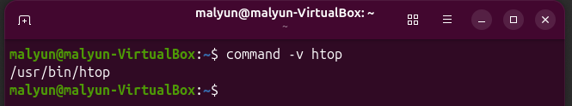

Important notes
- If command -v htop prints a path, htop is available.
- Some laptops require Fn with the function keys.

7. Foreground and background jobs
A foreground job uses the terminal directly. The shell waits until the command finishes, so you cannot type another command in that terminal. A background job runs without holding the terminal. Add an ampersand (&) at the end of the command to start it in the background.

Why do we use it?
Use background jobs when a task takes time but you still want to use the same terminal for other commands.
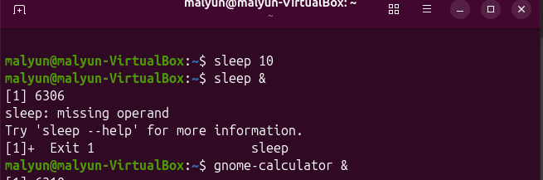
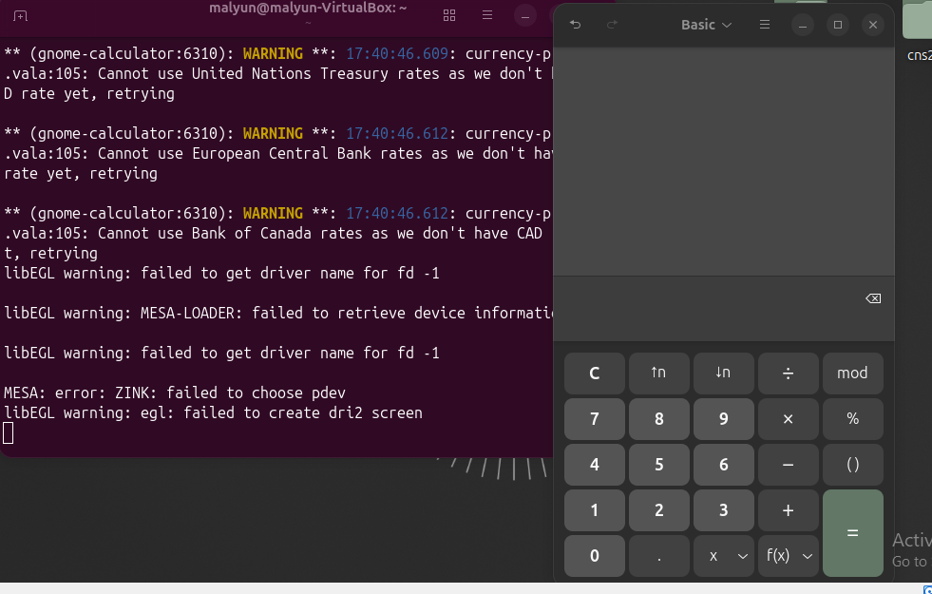

Options / keys
Option / key | Meaning
& at the end | Starts the command in the background.
[1] | The shell's job number.
PID printed after the job number | The process ID assigned to the background process.

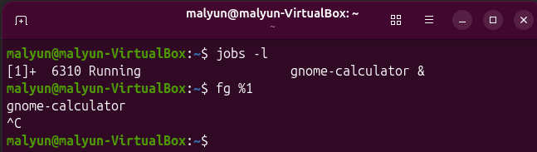

Important notes
- The ampersand must be at the end of the command.
- Job numbers belong to the current shell and terminal.

8. Ctrl+C and Ctrl+Z
Ctrl+C sends SIGINT to the foreground job. It asks the program to stop, and the terminal prompt usually returns. Ctrl+Z sends SIGTSTP. It pauses the foreground job and returns the prompt, but the process is not ended.

Why do we use it?
Use Ctrl+C when you want to interrupt a running command. Use Ctrl+Z when you want to pause a command and continue it later with bg or fg.

Options / keys
Option / key | Meaning
Ctrl+C | Sends SIGINT; interrupts the foreground job.
Ctrl+Z | Sends SIGTSTP; pauses the foreground job.
Stopped | The process is paused, not removed.

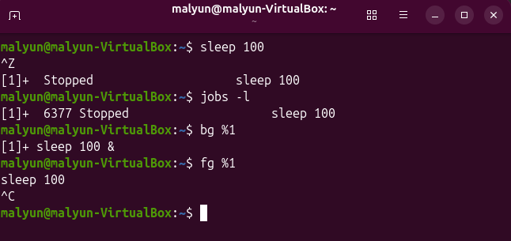

9. jobs, bg and fg
jobs lists the jobs managed by the current shell. bg continues a stopped job in the background. fg brings a background or stopped job to the foreground. A job can be selected by its job number, written with a percent sign.

Why do we use it?
Use these commands to manage tasks that you started from the current terminal.

Options / keys
Option / key | Meaning
jobs | Lists jobs in the current shell.
-l | Also displays each job's PID.
bg %N | Continues job number N in the background.
fg %N | Brings job number N to the foreground.
No %N | Uses the current job, usually marked with +.

Important notes
- Use fg %1, not fg 1.
- A job started in another terminal will not appear in this terminal's jobs list.

4.2 | SIGNALS, KILL, AND PRIORITY

10. Understanding Linux signals
A signal is a short message sent to a process by the kernel or another process. It tells the process that something happened or asks it to perform an action. Signals can request a normal stop, interrupt a task, or force a process to end.
Option / key | Meaning
SIGHUP (1) | Hang up. Some services use it to reload configuration.
SIGINT (2) | Interrupt. Often sent when the user presses Ctrl+C.
SIGKILL (9) | Force the process to end immediately. The process cannot catch or ignore it.
SIGTERM (15) | Ask the process to finish and exit normally. This is the default signal for kill.

Kill –l ,kill –l 15
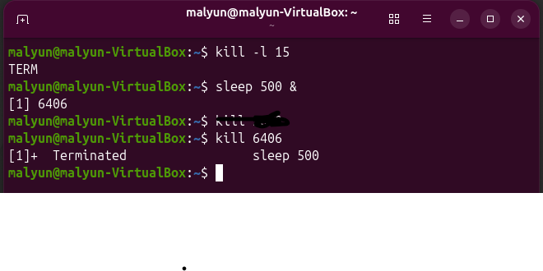
Important rule: use SIGTERM first. Give the program time to close files and save data. Use SIGKILL only if the process does not stop.

11. kill — send a signal by PID
kill sends a signal to a process. You identify the process by its PID. If you do not write a signal, kill sends SIGTERM (15). Despite its name, kill does not always force a process to stop; it sends the selected signal.

Why do we use it?
Use kill when you know the PID of the process you want to stop or signal.
kill PID
kill -TERM PID
kill -HUP PID
kill -9 PID
kill %1

Options / keys
Option / key | Meaning
No signal | Sends SIGTERM (15), the normal stop request.
-TERM | Sends SIGTERM by name.
-HUP | Sends SIGHUP; some daemons use it to reload logs or configuration.
-9 | Sends SIGKILL; force stop, last resort only.
%N | Targets a job number in the current shell.
sudo | Runs the command with administrator privileges when permitted.

Important notes
- Check the PID immediately before sending a signal; old PIDs may be reused.
- Do not use kill -9 first unless there is a clear reason.

12. killall and pkill — stop processes by name
When you know a process name but do not know its PID, killall or pkill can find matching processes. pgrep is useful for checking which processes match before stopping them.

Why do we use it?
Use these commands when a process name is easier to identify than its PID. Always inspect matches first because a name or pattern may match more than one process.

Options / keys
Option / key | Meaning
pgrep -a NAME | Shows matching process IDs and full command lines.
-a | Displays the command line with the PID.
pkill NAME | Sends the default signal to processes matching the pattern.
-u USER | Limits the action to processes owned by the selected user.
killall NAME | Targets processes with the exact process name.

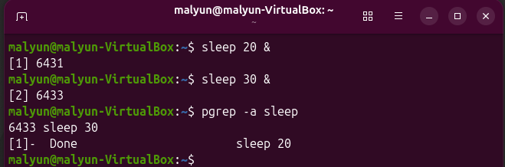

13. nice — start a process with a priority
Linux uses niceness to help decide how CPU time is shared between processes. The niceness range is from -20 to 19. A lower value is less nice and gives the process a higher scheduling priority. A higher value is more nice and gives the process a lower priority. The normal default is 0.

Why do we use it?
Use nice when starting a task that should use less CPU priority so that other work can receive more CPU time.

Options / keys
Option / key | Meaning
-n N | Sets the niceness value for the new command.
-20 | The highest scheduling priority in the niceness range; requires administrator permission.
0 | Default niceness.
19 | The lowest scheduling priority in the niceness range.

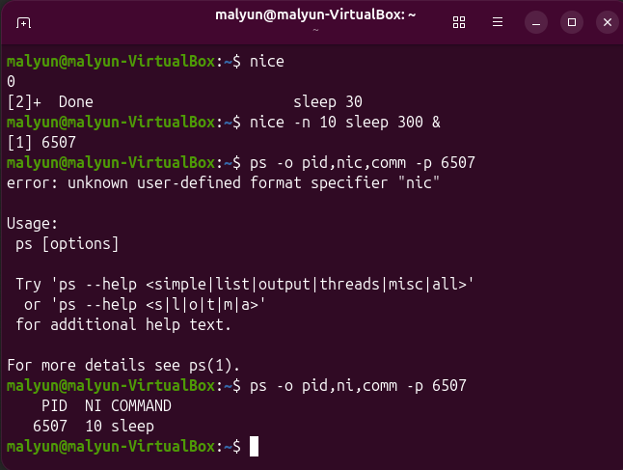

Important notes
- Higher niceness means lower priority, not higher importance.
- A normal user can usually increase niceness (make a process kinder).

14. renice — change a running process priority
nice sets priority when a new process starts. renice changes the niceness of a process that is already running. You identify the process by PID. A normal user can make their own process less important by raising its niceness. Lowering niceness usually needs administrator rights.

Why do we use it?
Use renice when a process is already running and you want to change how generously it receives CPU time.

Options / keys
Option / key | Meaning
-n N | The new niceness value.
-p PID | Selects the process by its process ID.
sudo | Can provide the administrator permission needed to lower niceness.

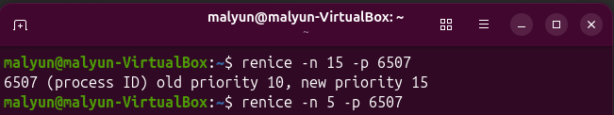

Important notes
- Check the NI column with ps or top after changing priority.
- Use the correct PID; do not copy an old PID from a previous terminal example.

4.3 | SYSTEM INFORMATION

15. Why system information matters
Before troubleshooting Linux, collect facts about the computer. Find the kernel version, hostname, time since boot, CPU count, RAM use and attached disks. These details help explain whether a problem is related to the operating system, memory, processor or storage.
Many system information tools read kernel information from virtual files under /proc and /sys. These are special kernel interfaces, not ordinary folders of saved documents.

16. uname — kernel and machine information
uname prints information about the running kernel and the machine architecture. It is useful when reporting a Linux problem because the kernel version and architecture can affect drivers and software compatibility.

Why do we use it?
Use uname to check the kernel release, machine architecture, hostname or all available fields together.

Command and syntax
Uname uname –m uname -a
Uname –r uname -n

Options / keys
Option / key | Meaning
-r | Prints the kernel release.
-m | Prints the machine hardware name or architecture, such as x86_64.
-n | Prints the network node hostname.
-a | Prints all available uname information on one line.

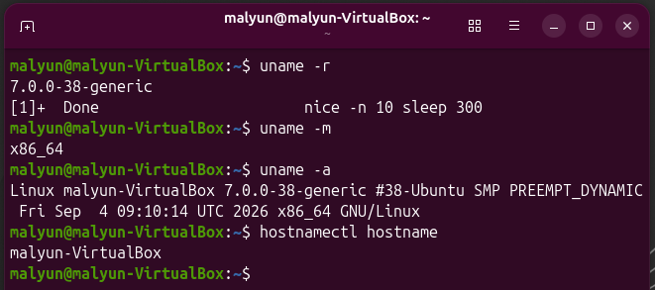

17. hostnamectl — system identity
hostnamectl displays information about the system hostname, operating system, kernel, architecture and virtualization environment. It can help you confirm whether Ubuntu is running inside a virtual machine.

Why do we use it?
Use hostnamectl to collect a short system identity report. This chapter reads the hostname only; changing it requires administrator permission.
Command : hostnamectl hostname

Options / keys
Option / key | Meaning
(no option) | Displays the full system summary.
hostname | Prints only the hostname.
sudo (when changing) | Administrator permission is required to change the hostname.

Important notes
- Do not confuse Operating System with Kernel; they are different details.
- Virtualization and hardware model fields can identify a VM.

18. uptime and load average
uptime shows the current time, how long the computer has been running, the number of logged-in users and the load average. The load average gives the average number of processes running or waiting for CPU or other resources over 1, 5 and 15 minutes.

Why do we use it?
Use uptime to see whether the machine has been running for a long time and whether system load is increasing. Compare load average with the number of CPUs.

Options / keys
Option / key | Meaning
-p | Shows time since boot in easy words.
-s | Shows the date and time when the system booted.
nproc | Prints the number of processing units available to the current process.
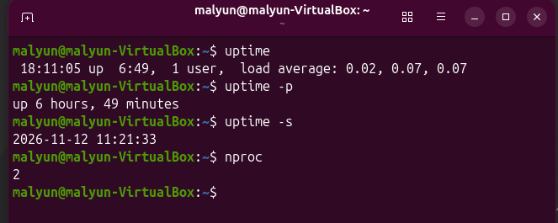

19. free — memory and swap
free reports RAM and swap memory use. The table includes total, used, free, shared, buff/cache and available memory. Linux uses some unused RAM for cache and can give it back when applications need it. Therefore, the available column is often more useful than the free column.

Why do we use it?
Use free when an application is slow or the system may be running out of memory.

Options / keys
Option / key | Meaning
-h | Displays values in human-readable units such as MiB and GiB.
-m | Displays values in mebibytes.
-s N | Repeats the report every N seconds. Press Ctrl+C to stop.

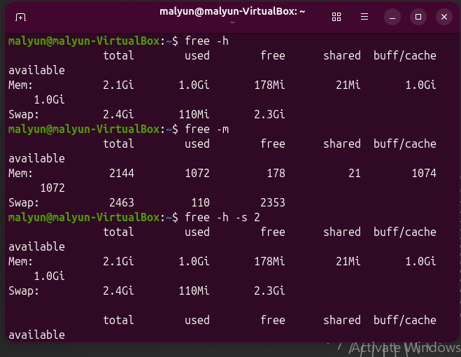

20. lscpu and nproc — processor details
lscpu displays a summary of the CPU architecture, number of CPUs, vendor, model and virtualization information. nproc prints only the number of processing units available to the current process.

Why do we use it?
Use these commands to understand the CPU capacity of the Ubuntu VM and compare it with the system load.

Options / keys
Option / key | Meaning
lscpu | Displays the full CPU summary.
| less | Shows long output page by page; press q to exit.
nproc | Prints only the available CPU count.

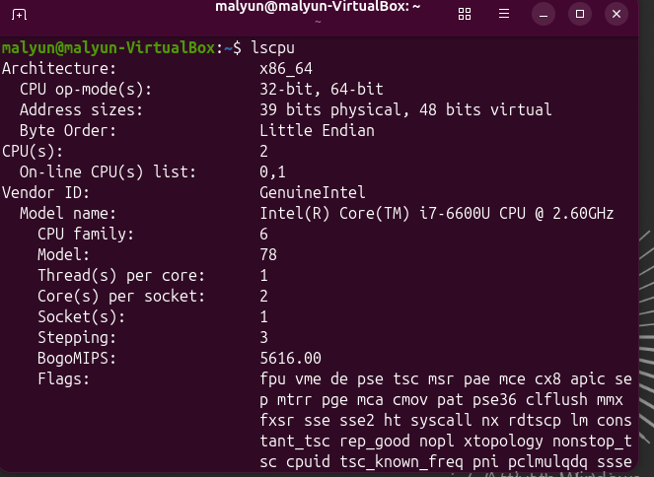
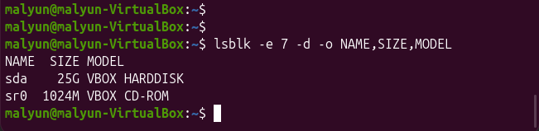

21. lsblk — list disks and partitions
lsblk lists block devices that the kernel can see. These include hard disks, partitions and optical drives. The tree structure helps you see which partitions belong to each disk.

Why do we use it?
Use lsblk to check which storage devices are attached to the system. This chapter only identifies disks; disk partitioning and mounting are studied separately.

Options / keys
Option / key | Meaning
-e 7 | Excludes devices with major device number 7, commonly loop devices.
-d | Shows whole disks only, not their partitions.
-o COLS | Selects output columns such as NAME, SIZE and MODEL.

22. /proc — the kernel's live information
/proc is a virtual filesystem created by the Linux kernel. It is not a normal folder stored on the disk. Its files provide live information about processes and system resources. Numbered directories usually represent process IDs.

Why do we use it?
Use /proc when you need to inspect raw kernel information or understand where commands such as free, uptime and ps obtain their data.

Options / keys
Option / key | Meaning
Numbered folders | Represent process IDs.
cpuinfo | Contains processor information.
meminfo | Contains memory information.
uptime | Contains time since boot.
loadavg | Contains load average values.

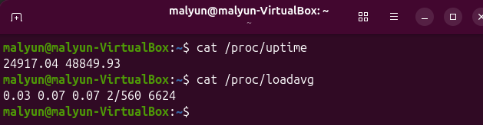

23. /proc/PID — inspect one process
Every running process has a directory in /proc named after its PID. Inside it, the kernel provides details such as the process name, state, PID and PPID. The special Bash variable $$ can be used to inspect the current shell.

Why do we use it?

Use /proc/PID when you want to examine a specific process directly through the kernel interface. Options / keys

Option / key | Meaning
status | Shows process name, state, PID and PPID, among other details.
comm | Contains the short command name.
cmdline | Contains the full command line.
exe | A link to the executable file.
$$ | Expands to the current shell's PID.

24. /proc/cpuinfo and /proc/meminfo
Some familiar commands are easier ways to read information from /proc. lscpu and nproc use CPU information. free uses memory information. uptime reads uptime and load average information.

Why do we use it?
Use these files when you want to compare the output of a command with the raw information provided by the kernel.

Options / keys
Option / key | Meaning
grep -m 1 | Stops after the first matching line.
-c | Counts matching lines.
^processor | The caret means the line must start with the word processor.
head -n 3 | Displays the first three lines.

25. /sys — devices and drivers
/sys is another virtual filesystem provided by the kernel. It organizes information about devices, drivers and hardware. The block category lists disks, while class/net lists network interfaces.

Why do we use it?
Use /sys to inspect how Linux represents hardware devices and network interfaces. This chapter reads these files only.

Options / keys
Option / key | Meaning
block | Contains block devices such as disks.
class | Groups devices by type.
class/net | Contains a directory for each network interface.
address | Contains the hardware/MAC address for an interface.

4.4 | SERVICES WITH SYSTEMD

26. What is a service?
A service is a program that runs in the background and waits for work. Examples include cron, a logging service and an SSH server. On Ubuntu, systemd is the service manager. The kernel starts systemd as PID 1, and systemd starts and watches services.
A systemd unit describes a resource that systemd manages. Service unit files normally end with .service. The unit file tells systemd what the service does and how to start it.
Linux kernel
↓
system (PID 1)
├── cron.service
├── rsyslog.service
├── systemd-journald.service
└── ssh.service (if installed)
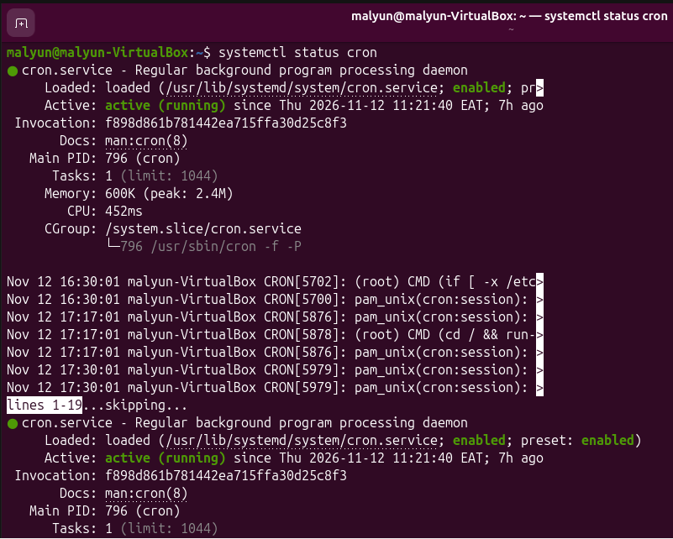

27. systemctl status — check a service
systemctl status is the first command to use when investigating a service. It shows whether the unit is loaded, whether it is enabled at boot, whether it is running now, its main PID and recent log messages.

Why do we use it?
Use status before changing a service. It gives you the current state and can show an early clue about a problem.

Options / keys
Option / key | Meaning
status | Displays detailed service status.
is-active | Prints whether the service is active or inactive.
is-enabled | Checks whether the service is configured to start at boot.
cat | Displays the unit file contents.
UNIT | The service name, for example cron or cron.service.

Important notes
- Active means running now; enabled means configured to start at boot.
- A service can be active but disabled, or inactive but enabled.

28. systemctl start, stop and restart
These actions change what a service is doing now. start starts it. stop stops it. restart stops it and starts it again. These operations usually require administrator permission, so use sudo.

Why do we use it?
Use start when a service is stopped, stop when it must be paused, and restart when it must be started again or its process needs a fresh start.

Command and syntax
sudo systemctl start UNIT
sudo systemctl stop UNIT
sudo systemctl restart UNIT
systemctl is-active UNIT

Options / keys
Option / key | Meaning
start | Starts the service now.
stop | Stops the service now.
restart | Stops and starts the service again; the process may receive a new PID.
sudo | Runs the command with administrator privileges.

29. reload or restart?
reload asks a service to read its configuration again without fully stopping. This can avoid interrupting existing connections. However, not every service supports reload. restart stops and starts the service, so it works more generally but may interrupt service for a short time.

Why do we use it?
Use reload when the service supports it and you want to apply configuration changes with less interruption. Use restart when reload is not supported or a full restart is required.

Command and syntax
sudo systemctl reload UNIT
sudo systemctl restart UNIT
sudo systemctl reload-or-restart UNIT

Options / keys
Option / key | Meaning
reload | Re-reads configuration if the service supports it.
restart | Stops and starts the service; creates a new process.
reload-or-restart | Reloads if supported; otherwise restarts.

30. enable, disable and --now
enable and disable control whether a service should start automatically during future boots. They do not normally start or stop the service immediately. Add --now when you also want to start or stop it now.

Why do we use it?
Use enable for services that should start automatically. Use disable when they should not start automatically. Use --now to combine the boot setting with an immediate action

Command and syntax
sudo systemctl enable UNIT
sudo systemctl disable UNIT
sudo systemctl enable --now UNIT
sudo systemctl disable --now UNIT

Options / keys
Option / key | Meaning
enable | Configure the service to start at boot.
disable | Remove the automatic start setting.
--now with enable | Enable at boot and start immediately.
--now with disable | Disable at boot and stop immediately.

31. list-units — list service states
systemctl list-units shows units currently loaded by systemd. You can filter the list to show only service units and only services in a selected state. This helps you find running services or failed services.

Why do we use it?
Use this command when you want a quick overview of services or need to identify failed services.

Command and syntax
systemctl list-units --type=service --state=running
systemctl list-units --type=service --state=failed

Options / keys
Option / key | Meaning
--type=service | Shows service units only.
--state=running | Shows services currently running.
--state=failed | Shows services that have failed.

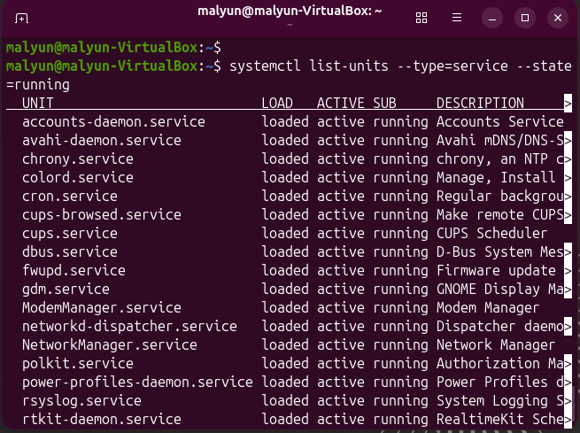

Important notes
- The list differs between Ubuntu installations.
- A failed service is a clue to investigate; read its status and journal.
4.5 | LOGS, BOOT, AND TROUBLESHOOTING

32. Why Linux logs are important
A log is a record of events that happen in the system. Linux records information from services, the kernel, logins and applications. Logs help administrators understand what happened before or during a failure.
This section uses three main sources: the systemd journal, text files under /var/log and kernel messages from dmesg. Read the logs before restarting or changing a service

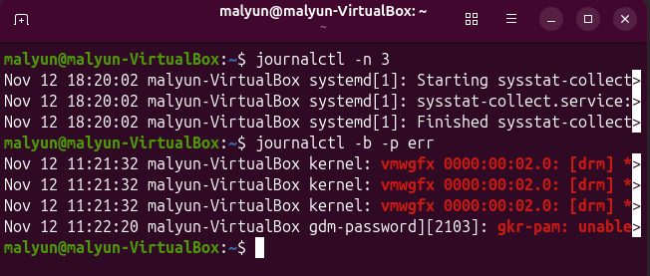

33. journalctl — read the system journal
systemd collects messages from the kernel and services in the journal. journalctl is the command used to read these records. Entries usually include a date, time, hostname, program name and message.

Why do we use it?
Use journalctl when a service fails, a system event occurs or you need to check errors from the current boot.

Command and syntax
journalctl
journalctl -n 3
journalctl -b
journalctl -b -p err

Options / keys
Option / key | Meaning
-n N | Displays the last N journal entries.
-b | Shows entries from the current boot.
-p err | Filters the journal to error priority and more serious messages.
q | Quits the pager when journalctl opens a long output.

34. journalctl -u — read one service's history
The -u option filters the journal by a systemd unit. This is useful after systemctl status shows a service problem. You can display recent entries or select a time period.

Why do we use it?
Use this command to focus on one service instead of reading all system messages.

Command and syntax
journalctl -u UNIT
journalctl -u UNIT -n 20
journalctl -u UNIT --since '1 hour ago'

Options / keys
Option / key | Meaning
-u UNIT | Shows entries for one service or unit.
-n N | Shows the most recent N entries.
--since | Shows entries after a time or date expression.
Quotes | Keep a phrase such as '1 hour ago' together as one argument.

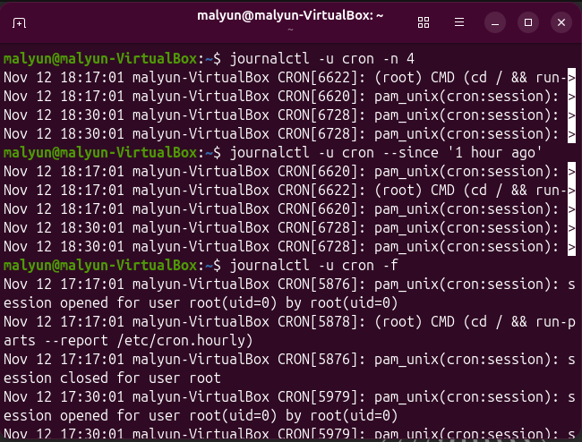

35. journalctl -xe and -f
-xe opens the journal near the newest entries and adds explanatory information where available. The -f option follows the journal live. New entries appear as they are written. Ctrl+C stops live following.

Why do we use it?
Use -xe just after an error appears. Use -f when you want to watch new events while performing a test in another terminal.

Command and syntax
journalctl -xe
journalctl -f
journalctl -u UNIT -f
logger 'week 8 test from student'

Options / keys
Option / key | Meaning
-e | Jump to the end of the journal.
-x | Add explanatory text where available.
-f | Follow new journal entries live.
logger | Writes a test message to the system log.
Ctrl+C | Stops live following.

36. /var/log — text log files
Ubuntu can also store traditional text logs under /var/log. These files can be read with commands such as less, tail and grep. Common files include syslog, auth.log and kern.log.

Why do we use it?
Use /var/log when you need to inspect system messages, login activity or kernel messages in text-file form.

Command and syntax
ls /var/log
less /var/log/syslog
tail -n 3 /var/log/kern.log
tail -f /var/log/syslog

Options / keys
Option / key | Meaning
syslog | General system messages.
auth.log | Authentication events, logins, sudo and SSH activity.
kern.log | Kernel messages.
journal/ | Files used by the systemd journal.
tail -n 3 | Shows the last three lines.
tail -f | Follows new lines as they are added.

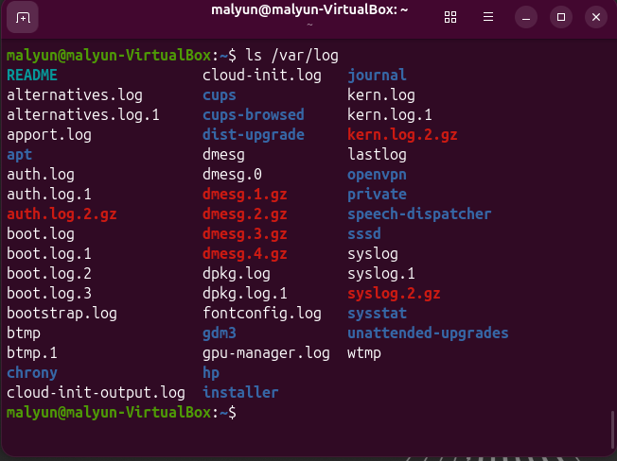

37. auth.log and last — login and sudo records
auth.log records authentication events such as logins and sudo commands. The journal can also contain these records. The last command reads login history, including information about users and reboots.

Why do we use it?
Use these commands when you need to check who used sudo, which command was run, or when a user logged in.

Command and syntax
grep sudo /var/log/auth.log | tail -n 1
journalctl _COMM=sudo -n 1
last -n 2

Options / keys
Option / key | Meaning
grep sudo | Finds lines containing the word sudo.
| tail -n 1 | Shows the newest matching line from the filtered output.
_COMM=sudo | Filters journal entries by the command name sudo.
last -n 2 | Shows the two most recent login or reboot records.

38. dmesg — kernel messages
dmesg displays messages from the kernel ring buffer. These messages can describe hardware detected during boot, drivers being loaded and devices appearing. Ubuntu may restrict access for normal users.

Why do we use it?
Use dmesg when investigating hardware or driver problems. You can also read kernel messages from the systemd journal.

Command and syntax
dmesg
sudo dmesg -T | tail -n 2
sudo dmesg | less
journalctl -k -b

Options / keys
Option / key | Meaning
-T | Shows readable clock times instead of time values in seconds.
tail -n 2 | Shows the two newest lines.
less | Reads long output page by page.
-k (journalctl) | Shows kernel messages only.
-b (journalctl) | Limits messages to the current boot.

39. shutdown, reboot and poweroff
Linux should be shut down from inside the operating system. A clean shutdown allows services to stop in order and gives the system time to write data safely. Turning off a VM directly is similar to removing power from a physical computer.

Why do we use it?
Use shutdown to schedule a shutdown or reboot. Use reboot to restart immediately and poweroff to switch off the system.

Command and syntax
sudo shutdown now
sudo shutdown +5
sudo shutdown -r +5 'Rebooting for the lab'
sudo shutdown -c
sudo reboot
sudo poweroff

Options / keys
Option / key | Meaning
now | Shut down immediately.
+N | Schedule shutdown in N minutes.
-r | Reboot instead of powering off.
-c | Cancel a scheduled shutdown.
reboot | Restart the system now.
poweroff | Shut down and power off now.

40. Troubleshooting a service
When a service does not work, follow the same order each time. First check its current status. Then read its journal to find the first error. Finally, inspect the relevant configuration area. This is safer than restarting services without understanding the problem.

Why do we use it?
Use this method for SSH or cron. The exact service name and configuration directory depend on the service.

Command and syntax
systemctl status ssh
journalctl -u ssh -n 30
ls /etc/ssh
sudo sshd -t

Options / keys
Option / key | Meaning
Step 1: status | Check whether the service is active, failed or inactive.
Step 2: journalctl | Read recent messages and look for the first error.
Step 3: configuration | Check the relevant configuration files.
sshd -t | Tests SSH server configuration syntax; no output means the test passed.

41. Troubleshooting a slow machine
When Ubuntu becomes slow, check load, memory and the busiest processes before changing anything. This order narrows the problem. uptime shows load average, free shows memory availability, and top shows which processes are using resources.

Why do we use it?
Use this sequence to decide whether the system is busy because of CPU load, low memory or one process using too many resources.

Command and syntax
uptime
nproc
free -h
top

Options / keys
Option / key | Meaning
uptime | Check the 1, 5 and 15 minute load averages.
nproc | Find the number of available CPUs for comparison.
free -h | Check available RAM and swap use.
top | Press P to sort by CPU or M to sort by memory.

